Wirral MIG/HIE
Integrated Privacy Notice

You have told us you don’t want to have to tell your story every time you see a different doctor, nurse, visit hospital or A&E; this can be stressful and takes a long time.
The reason you’ve had to do this up until now is because every health care organisation holds a different set of records about you.
The Wirral MIG/HIE Project will enable us to bring together your information and present this to the professional caring for you, but only once they have your permission and if your GP practice have agreed to enable this.

How it works
The Wirral MIG/HIE Projectsecurely connects Wirral GP Practices and Wirral University TeachingHospital’s computer systems together.

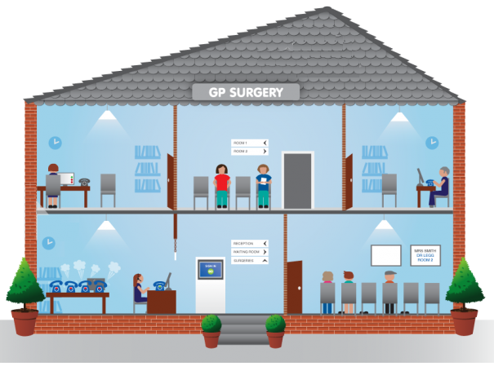

When your records are requested, it collects the information from the different systems and shows the information to the requestor. None of the information it collects is stored and none of it can be changed. Because it collects the information only when it is needed, the information is always accurate and as up to date as possible.
Before any information is collected or displayed to a care professional, that professional must either have your consent to view your record, or record a specific reason for viewing your record without your consent. Your consentorany specific reasons for viewing without your consent are recorded on the system, so that we know exactly who has accessed what information and when.

The Wirral MIG/HIE Project uses the secure NHS network to retrieve the information and displays a read only view for the care professional to use to support the delivery of care at that specific point in time.

What information will be shared?
The sharing will allow:

GP Practices to see the following information from Wirral University Teaching Hospital:

- Visits
- Future Appointments
- Laboratory Results
- Radiology Results
- Microbiology Results
- Discharge Summaries
- Medications
- Allergies
- Diagnoses
- Procedures
- Immunisations
- Vital Signs

Wirral University Teaching Hospital to see the following information from GP Practices:

- Patient Details
- Summary View including current problems, current medication, allergies and recent tests
- Problem view
- Diagnosis view
- Medications including current, past and relevant issues
- Risk and Warnings
- Procedures
- Investigations
- Examinations (Blood pressure only)
- Events consisting of visits, admissions and referrals

Certain types of “highly sensitive” information will be restricted from sharing under this agreement.

Who is involved?

- NHS Wirral Clinical Commissioning Group GP practices that have signed up to the Information Sharing Agreement and opted to enable information sharing
- Neston Medical Centre/Neston Surgery (members of West Cheshire Clinical Commissioning Group)
- Willaston Surgery (members of West Cheshire Clinical Commissioning Group/part of Bridgewater Community Healthcare NHS Trust)
- Wirral University Teaching Hospital NHS Foundation Trust
Wirral Clinical Commissioning Group is encouraging all Wirral GP practices to take part. The more patient records that are shared in this way, the more likely your care provider will find the information needed to provide you with better quality and more effective care.

Not all care providers can view the shared information. It is only available to the care organisations in Wirral that have signed up to the Information Sharing Agreement.

Will my Information be shared with other NHS organisations or third parties?
Wirral University Teaching Hospital may share only selective relevant amounts of your health information to another NHS hospital, only if the other NHS hospital is actively treating you and it is determined to be helpful towards the care they provide you.

Outside of this your Information will only be shared between Wirral University Teaching Hospital and your own specific registered Wirral GP Practice, it will only be available to clinicians directly involved in your care. It will not be shared between other GP practices, or any third party non NHS organisations.

Can I refuse to allow my records to be shared?
If you are concerned about sharing your GP and Hospital records you can opt out of allowing them to be shared. If you do not wish for your information to be shared,then please contact your GP practice who will arrange this. This can be done at any time – now or in the future.

When and how will healthcare professionalswant to view my record?
Normally if you are directly in front of a healthcare professional you will be asked directly to give your explicit consent, at the point of contact, for your record to be viewed. You can say “yes” or “no”; the healthcare professional will only view your record if you say yes.

There will also be instances where your own specific GP Practice Healthcare professionals require to view your record without your presence or direct explicit consent, for example to advance their knowledge of your specific clinical situation prior to visiting you at home or determining a prescription of medications for you.

All Healthcare professionals will also view your record without your direct consent in emergency situationsif it is deemed vital to provide appropriate care for you. For example if you are unconscious and unable to provide explicit consent.

In both these instances, the healthcare professional must state a reason why direct consent has not been obtained (e.g., “viewing patient’s record prior to making home visit” or “patient is unconscious”). All specified reasons are logged in the system and are fully auditable.

The healthcare professional is only viewing your record in a single session; they are not downloading, amending or storing any of your data. This means that when they close your record it is no longer accessible for that specific session. To access it again in a future session the healthcare professional will have to ask for your explicit consent or state a new reason for accessing it without your direct consent.

For Further Information
Please see our leaflet

For further information you can discuss the sharing of your records with your GP.

